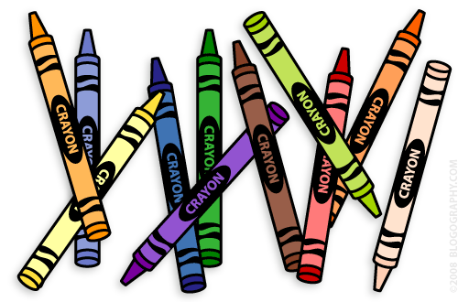
Our 1st Grade Classroom News
The Week of Apr. 3rd – 7th
Email: Lweeks@bluevalleyk12.org
Website: www.bluevalleyk12.org/hes/lweeks

- We will be working on plural words this week!

-Field Day t-shirt order forms were sent home a while ago and are due on Wednesday, April 19th.

-We could still use some stools for our classroom if you have any you can donate! Our old ones have almost all broke! Any kind of stool would work at this point!

- Starting on April 13th, we will be completing ABC Days of 1st Grade! This is a way to make each day fun and exciting up until the last day of school! See the attached paper for details. PLEASE keep this paper in a visible place for your child to see on a daily basis.

Important Info
Upcoming Events

- THIS website is actually one I use every day with the kids. It has amazing online resources and free access to websites that you usually have to pay for. My favorites are tumblebooks and bookflix to use with the kids!
http://kslib.info/kids

- Tell About This is a great app that the students have enjoyed in the past. Students can pick a picture, write a few sentences about the picture, and record themselves reading what they wrote. They are able to save what they recorded so they can go back and see what they have done in the past well.

Tech of the Week
Math Challenge of the Week: We have been working on graphing the last couple of weeks. Have your child ask your family what their favorite color is. Then have them create a bar graph explaining their results. Make sure they make a title for their graph and they also label each side of the graph as ‘colors’ and ‘number of people’. To see an example of what I am talking about, check the link: https://goo.gl/mSdR0D
Reading Challenge of the Week: We will be talking a lot of about quotation marks in the next week or so. Have your child find any sentence with quotation marks and write them down in a list. Have them try to find at least 4 different sentences that have quotation marks.

Writing Challenge of the Week: Have your child come up with questions (at least 4 questions) to ask someone in your family or a friend. Then have them ask the person the questions and write down the answers that they gave.

Challenges of the Week

Apr. 13th ABC Days Start
Apr. 17th Field Trip to Folly Theater
Harmony 25th Anniversary (4-6pm)
Apr. 18th Early Release Day
Apr. 19th Field Day t-shirt order forms are due
Apr. 20th 1st Grade Musical @ 2:45 in the Gym
Apr. 21st MAP testing – reading (am)
Apr. 24th No School
Apr. 26th MAP testing – math (pm)

